* Database Module 11_2
  + Charlie Group
    - Jacob Breault
    - Cameron Frison
    - Skyler Millburn
    - Angela Perkins
    - William Silknitter III

We are Charlie Group; Our team is made up of Jacob Breault, Cameron Frison, Skyler Millburn, William Silknitter III, and me, Angela Perkins.

Our group went with the case study Outland Adventures. Outland Adventures is a business that puts customers in reach of the trip of a lifetime! Their talented staff gets customers set up with the trek of their choice and offers gear for purchase to make that trek more enjoyable. Like any smart business, they have decided to review their records so they ensure their company grows and thrives by focusing on treks with the highest amount of booking, and determining if offering equipment is the right thing to do financially.

The questions put forth by Outland adventures included:

Whether enough customers bought equipment to continue with sales

If any of their locations have have a downward trend in booking

If any of their inventory more than 5 years old

When we set up this database, we looked at more than just the questions asked in the assignment, and added tables to maintain employee records, keep track of who was leading the treks. In retrospect, we probably added more tables than really required to answer the questions, but to be a good business solution for Outland Adventures.

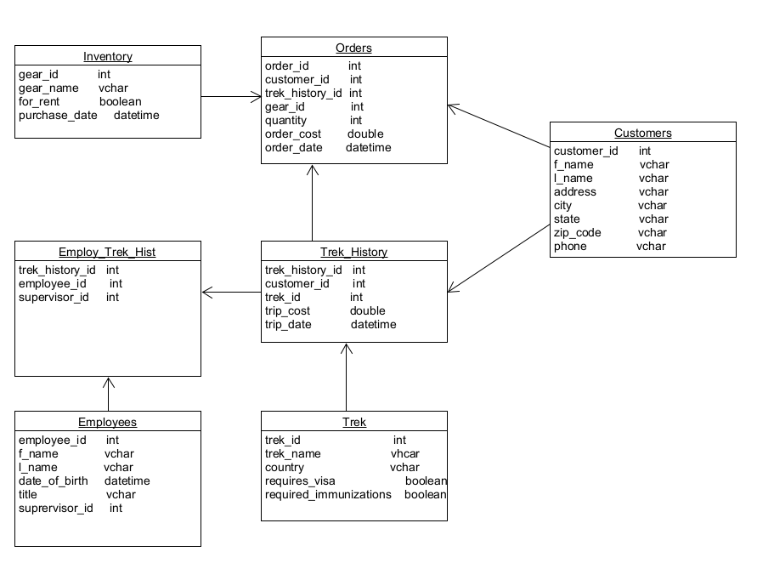

That being said, we did make sure our tables did contain the data to answer their questions, so we generated the following reports:

1. Inventory Name and Quantity Ordered:
   1. Our report returns the name of the gear, what the order ID was, and how many pieces were ordered. This information will help Outland Adventures determine what gear is selling well, so they can make an informed decision on what to carry.

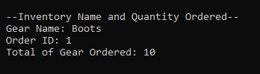

1. Customers on Each Trek
   1. This report gives the trek name, location, date, and number of customers on each track. This will help them find which destinations are most popular and see if any locations have a downward trend in bookings during specific times of year.

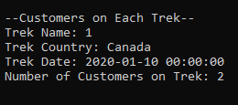

1. Gear Purchase Dates:
   1. We broke this down into two reports; Gear purchased before 2016, and all gear purchase dates. While they return the same fields of Gear ID, Gear Name, and Purchase Date, the gear purchased before 2016 report will help them quickly identify potentially dangerous gear.

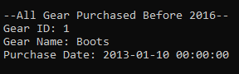

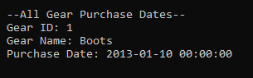

1. How Many Treks and Amount Spent Per Customer
   1. This was a report that we could see adding great value to Outland Adventures! The report basically finds their VIP customers by providing a total of how many treks and how much money was spent on the treks by customer. We all know those VIPs might enjoy special perks on their next trip and are who we should be targeting in our marketing.

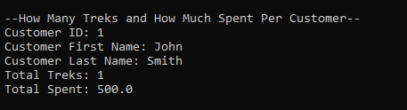

This was very interesting in part because although the information in the reports are basic performance metrics for a business, one does not necessarily think of the databases and queries behind gathering all this information. We certainly had some lessons on the way as well; late into the game, we changed some of the fields in our table and found they broke queries that we thought were about ready to roll. Additionally, we found that there were some hiccups in communication that put us a bit behind on our timelines. Overall, I do believe Charlie Group was able to deliver for Outland Adventures!